Fraternal Order of Police
Wally Rolniak Southeastern Lodge #6
26th Annual
Rich Hall Memorial Golf Outing and Fundraiser
Hole Sponsor Form
29 June 2021

Sponsorship packages are listed below with details of what’s included in each package:

Platinum Level $1000 (You are an Outing Sponsor)

- Individual Sign indicating as a Hole Sponsor.
- Your company name on our master listing prominently displayed at the event.
- Four golf outing tickets, which include: golf, cart, lunch, dinner, complimentary beer, pop, and water on course, 2-hr open bar with dinner and door prizes.
- On board filled Booze 20 shot bottle cooler for beverages on day of event
- Each cart will have a 12pak of Premium Brand Golf balls on the course.

- Your sign to read: ________________________________________________

Gold Level Sponsor: $750 donation

- Individual Sign indicating as a Hole Sponsor.
- Your company name on our master listing prominently displayed at the event.
- Four golf outing tickets, which include golf, cart, lunch, dinner, complimentary beer, pop and water on the course, two-hour open bar with dinner and door prizes.

- Your sign to read: _______________________________________________

Silver Level Sponsor: $500 donation
- Individual Sign indicating as a Hole Sponsor.
- Your company name on our master listing prominently displayed at the event.

- Two golf outing tickets, which includes golf, cart, lunch, dinner, complimentary beer, pop and water on the course, two-hour open bar with dinner and door prizes.

- Your sign to read: _______________________________________________
Bronze Level Sponsor: $100 donation

Your name on our master listing prominently displayed at the event.
Your sign to read: _______________________________________________

To become a Hole sponsor, please make your check payable to:

F.O.P. #6 Golf Outing.

Company logos can be emailed to il.wrse.fop6@gmail.com no later than 01 June 2021 for Full Color Platinum, Gold, or Silver signs.

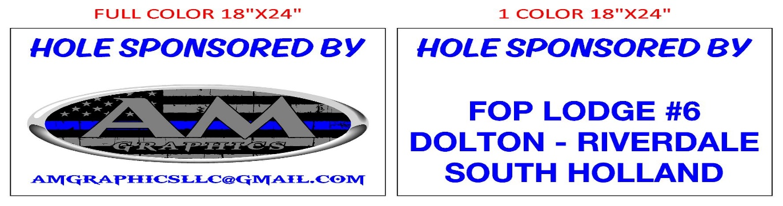

Please mail your donation to:
Wally Rolniak SE FOP 6
Attn: Golf Outing Committee
725 West 138th Street
Riverdale, IL 60827

